New Method for Calculating “nearly LTHAD” [to be used for SWOs after 20 Mar 2014]

(1) plot case study using the recommended Mercator Projection

(2) plot map background with lat/lon plotted every 2 degrees

(3) save and print THAD map, being careful NOT to use a dark background

THAD = ADV (SUB(HGHT@500%PRES,HGHT@1000%PRES), GEO@1000%PRES )

(4) before exiting GARP, be certain to NOTE the number of kilometers covering a distance of 2 degrees longitude [=dd] in the region of the cyclone (as always, this is done using the “+” marker by clicking on the mouse and then moving the pointer 2º longitude away [along the same latitude] )

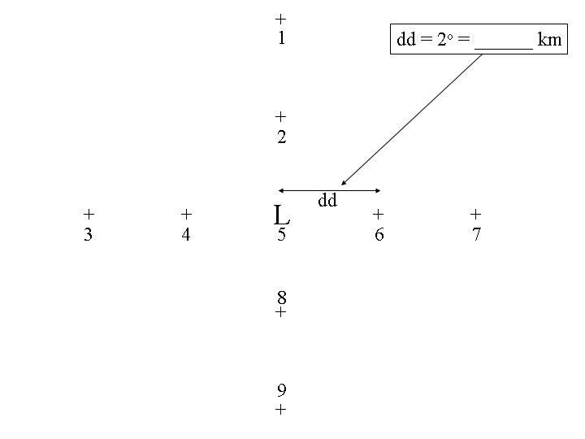
(5) You will need to determine THAD at Points 1, 3, 5, 7, and 9 shown in the diagram above. Next, you’ll compute dTHAD/dd at Points 2, 4, 6, and 8 remembering to have “dd” in the proper units and making certain that your derivative is covering the proper horizontal distance. Finally, you’ll compute d [dTHAD/dd] /dd at Point 5 (the predicted cyclone center position) using the dTHAD/dd points calculated at the four surrounding points (2, 4, 6, and 8).

(6) The result from Steps (1)-(5) will give you an estimate of “nearly LTHAD.” You’ll need to multiply by the proper term to get LTHAD, as we have done previously throughout the semester.

