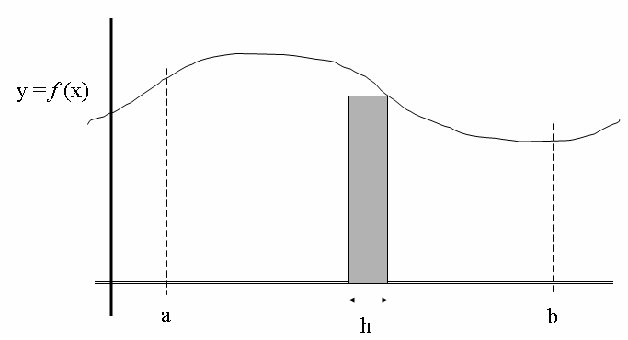
Composite Trapezoid Method

When estimating an integral involving observations,
$I(f) = \int{f(x) \text{dx}}$,

there’s an approximation that must be made known as the Composite Trapezoid Method (T_{N}),

$$I(f) ≈ T_{N} = h \sum_{i=1}^{N−1}{f_{i} + \frac{h}{2}} \left(f_{0} + f_{N}\right), h = \frac{b−a}{N}$$
since our observations are not located continuously in any direction (north/south, east/west, up/down, forward/backward in time). This approximation essentially estimates an integral by summing up a bunch of rectangles whose height is given by the function involving our observation { f (x) }and whose width is the distance between observing stations { in our simple world we’ll initially assume these to be on regularly-spaced locations, such as every 20º longitude }. Note that the weather obs locations at the limits (a and b) of integration correspond to functions involving observations labeled in the formula as “f ₀” and “f _{N}”. In some special cases, the weather obs locations at the limits of integration might be at the SAME LOCATION {golden nugget}.

