New Method for Calculating “nearly LTHAD” [to be used for SWOs after 21 Mar 2024]

(1) plot case study using the recommended projection

(2) save and print the thickness advection (THAD) map using a nine-point smoother on THAD via python; thad_sm = mpcalc.smooth_n_point(thad, 9, 11) #Use a nine-point smoother eleven times

(3) assume 1 degree longitude equals 111 km [cos(Φ)], where Φ is latitude, and 1 degree latitude equals 111 km

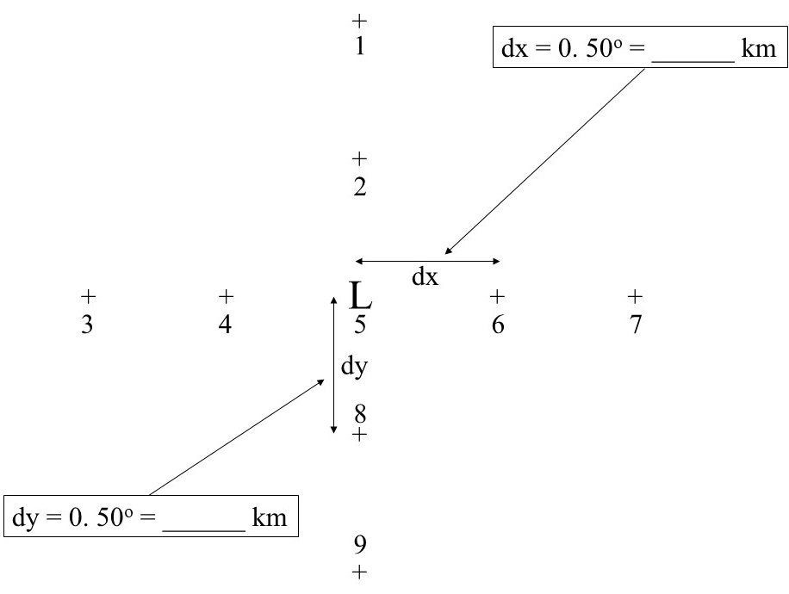
(4) You will need to determine THAD at Points 1, 3, 5, 7, and 9 shown in the diagram above. Next, you’ll compute dTHAD/dx (dTHAD/dy) at Points 4 & 6 (2 & 8), remembering to have “dx” and “dy” in the proper units and making certain that your derivative is covering the proper horizontal distance. Finally, you’ll compute d[dTHAD/dx]/dx & d[dTHAD/dy]/dy at Point 5 (the predicted cyclone center position) using the dTHAD/dx & dTHAD/dy points calculated using the four surrounding points (4, 6, 2, and 8).

(5) The result from Steps (1)-(4) will give you an estimate of “nearly LTHAD.” You’ll need to multiply by the proper term to get LTHAD, as we have done previously throughout the semester. You must show ALL mathematical steps (original numbers at each point and calculations) as part of your case study report.

