Names:_______________________________________ Activity#7
Applied Numerical Weather Prediction Due: 4 April 2022

Model Physics

(7.1) The winds along the coast are calm just as the sun begins to rise on a clear, tranquil summer day. Initially, the pressure surfaces are flat. Describe how the pressure surfaces and winds change as the sun rises. Document the important heat transfer mechanisms (radiation, conduction, convection) and note the important processes from Kalnay’s Figure 4.1.1 (Slide #5 of LP #7) related to this scenario as the sun is rising.
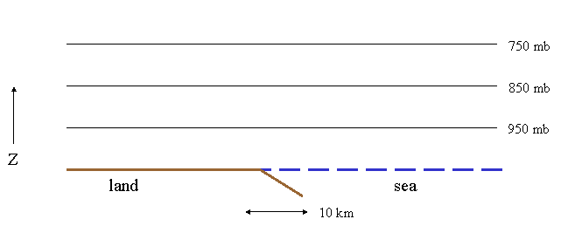

(7.2) Based on the description given in Problem (7.1), determine the processes that are likely to fall into the grid or subgrid-scale portion of a computer weather model running for the coastal domain with a horizontal grid spacing of 15 km.

[q7.2.1] How does the presence of clouds complicate the simulation?

[q7.2.2] If computer resources were not a factor (computers were perfectly powerful) and you could decrease horizontal resolution to 1.0 meter, what process(es) in this weather scenario would be most likely to fall into the subgrid-scale portion of a computer weather model for this domain?

