**Names:_______________________________________ Activity#6**

**Applied Numerical Weather Prediction Due: 23 March 2022**

**Boundary Conditions**

**(6.1)** Create a weather forecast model that will predict the zonal wind and displacement (*η*, analogous to pressure) based on the 1D barotropic primitive equations without advection or Coriolis…



$$η\left(x, t_{0}\right)=0.9 m, 365 ≤i ≤375; 0.0 m, otherwise$$

$$u\left(x, t_{0}\right)=0.0 m s^{-1}, everywhere$$

with a horizontal grid spacing (Δx) of 3 km* on the staggered grid shown in Fig. 9.1 of the D&VK textbook, 401 grid points for *η* and 402 grid points for *u*, and a time step (Δt) of 5 s, with *forward-in-time* and *centered-in-space\*\** differencing schemes. Use a depth *H* of 5 meters and a gravitational constant of 9.81 m s-2. Note that the analytic function for “*u*” and “*η*” is to be applied **only at the initial time** (*t* = *t0* = 0). Integrate the model out through 30000 seconds and plot the numerical displacement (*η*) at the final forecast time (t = 30000 seconds) using the following types of boundary conditions (BCs),

[q6.1.1] fixed or rigid BCs (p. 152 of D&VK textbook) and

[q6.1.2] radiation BCs (pages 151-154 of D&VK textbook), applying Eqs. (9.9) and (9.10) from the textbook.

[q6.1.3] What (if any) differences exist between the 30000 s forecast using the two types of BCs? If there are differences, what is the primary reason for the difference in the forecasts? Does either simulation completely eliminate reflection of the displacement peak moving toward the domain boundary [find support for your answer in Chap. 9 of the D&VK textbook]?

[q6.1.4] What happens to the displacement (*η*) at locations of horizontal wind convergence? [examine Eq. (9.6) closely]

*3 km is the horizontal grid spacing between grid points having the same variable (zonal wind or displacement)

\*\**centered-in-space* on a staggered grid appears like forward- or backward-in-space differencing, depending on whether you are calculating the displacement or zonal wind gradient term

Fig. 6.1 (Fig. 6.2) shows what your weather forecast model would produce at a forecast time of 5000 (30000) seconds if it were properly coded and was initialized with the displacement (analogous to pressure) peak **in the center of the model domain**.

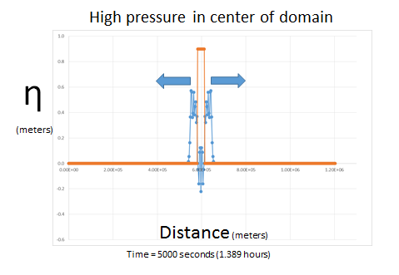

**Figure 6.1.** Displacement (*η*) after 5000 seconds of time integration (blue) of a displacement peak started in the model domain center (gold). The primary displacement (pressure) peak splits into two secondary peaks, one propagating to the right (downstream or east) and one propagating to the left (upstream or west). Arrows indicate direction of propagation of secondary displacement peaks.

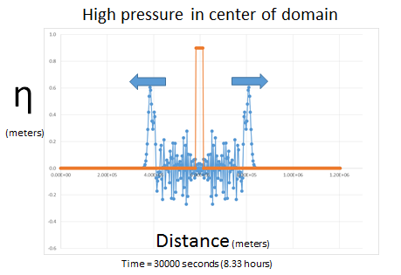

**Figure 6.2.** As in Fig. 6.1 except after 30000 seconds of time integration (blue).